Utilization of Filters

"Utilization of filters" refers to the use of filters and slicers to display specific subsets of data according to selected criteria. Filters allow users to interactively analyze student performance and engagement without changing the underlying dataset. The dashboard contains interactive filters for:
- Gender
- Engagement Level
- Region
- Performance Level
- Risk Level
- Final Result
When a filter is selected, the KPIs and visualizations dynamically update according to the selected category. This helps users compare different student groups and identify specific performance and dropout patterns. For example, selecting a particular engagement level allows the user to analyze the corresponding student count, average score, clicks, performance, and other metrics.
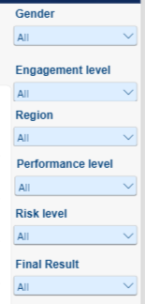

Power BI Dashboard Filters — Gender, Engagement Level, Region, Performance Level, Risk Level, and Final Result

"The Power BI dashboard implements interactive slicers and filters to provide self-service root-cause analysis without altering the underlying raw data architecture. By exposing filters for Gender, Region, Engagement Level, Performance Level, Risk Level, and Final Result, users can dynamically isolate specific cohorts within the 26,074 unique students.

For example, an educator can filter for students flagged as 'High Risk' who also fall into a 'Low' Engagement Level category. Power BI dynamically recalculates core performance metrics—such as the avg_score, studied_credits, and final categorical outcomes (final_result)—on the fly.

This interactive slicing empowers stakeholders to move seamlessly from macro-level regional overviews down to hyper-targeted student risk clusters."

